ROUND ROCK ISD GRADUATION REQUIREMENTS
Foundation Course Requirements | Distinguished Level of Achievement (DLA)  ***this is the sequence of courses we recommend***
English | Eng. I, 2, 3, 4 (4 credits)
Math | Alg. I & 2, Geom. & Adv. Math (4 credits)
Science | Bio., IPC or Adv. Sci., & 2 Adv. Sci.(4 credits)
Social Studies | W. Geog, W. Hist, U.S. Hist., Govt/Econ. (4 credits)
Languages Other Than English (LOTE) | Same language for 2years (2 credits)
Fine Arts | Fine Arts (1 credit)
Physical Education | Phys. Edu. (1 credit)
Electives | Electives (7 credits)
Endorsements  Note: See detailed resources on requirements on the back of this page  ***these are not additional classes, these classes are usually satisfied with the core and/or elective classes | >STEM  >Business & Industry  >Arts & Humanities  >Public Service  >Multidisciplinary
Cumulative Credits | 27

Sample 4yr plan
This is a sample of a basic plan. There are multiple routes to meet the requirements for graduation. You will work with your counselor at 1 on 1 conferences to select appropriate courses for your plan.

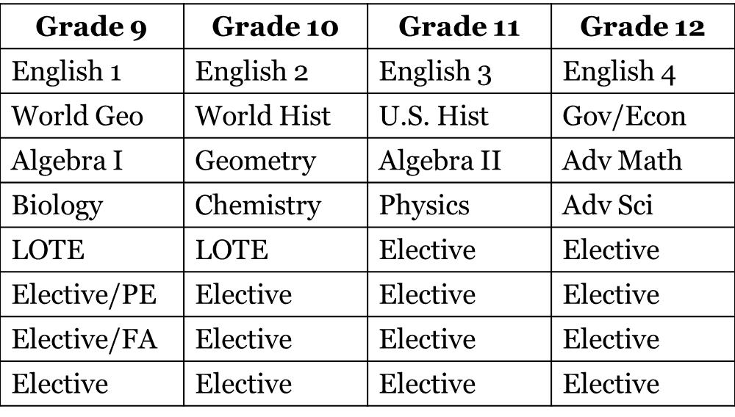
Important things to remember:
-If you are feeling worried about your children’s classes for next year, at your 1 on 1 conference, your child’s counselor will meet with you and be able to answer all your questions before final classes decisions are made
-Every year after this, we will always have a 1 on 1 conference with you and your student to go over additional questions, course selection, college guidance, scholarships and much more
-Remember to pick the best classes for your child! Not what worked for your other children, your neighbor, or friends….class selection is a very individualized process
-When picking classes, don’t let your child be overloaded in their work load. The transition from middle school to high school is a lot to process, so taking 5 advanced level classes on top of multiple extracurricular activities will just make it more stressful.

